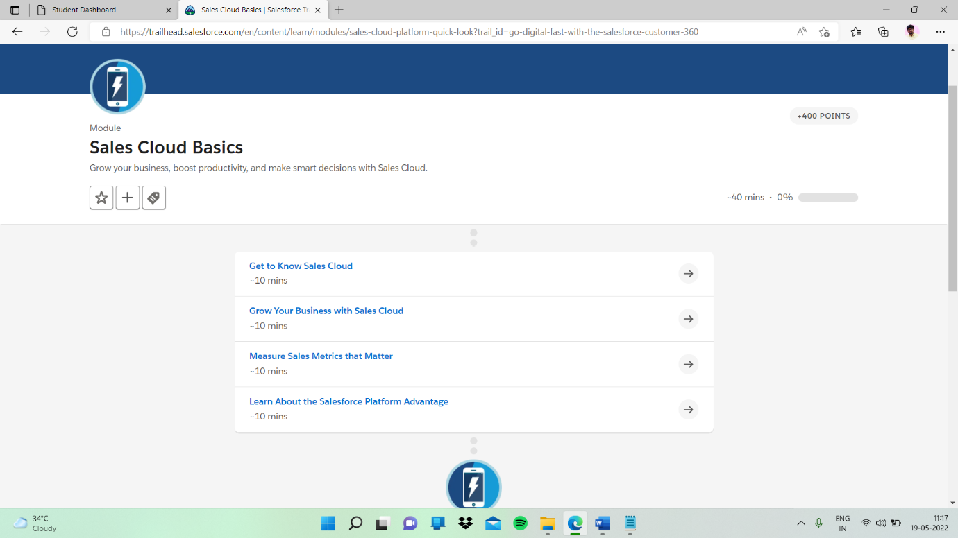

Sub topic :- Measure Sales Metrics that Matter

In this given quiz I completed

